**WEEK 3 VIDEO 1**

**Introduction to ServiceNow**

In this lecture, we will be covering:

* What is ServiceNow?
* Services of ServiceNow
* How to get a ServiceNow instance?
* Career and Growth in ServiceNow
* ServiceNow UI overview
* ServiceNow components
* Modules

1. Incident Module
2. Problem Module
3. Change Module

* Lists

**What is ServiceNow?**

* ServiceNow is a cloud-based platform, which was mainly developed for workflow and process automation as per the ITIL principles.
* ServiceNow contains a dedicated workflow available which we have to learn and which we need to apply on the logics which we are going to develop so this provide.
* It provides PaaS which is one part of cloud where you will have to create your own application on that particular platform and that platform will automatically host your application on the cloud without writing a single line of code.

**Services of ServiceNow:**

* ITSM(IT Service Management):

One of the basic and important services provided by ServiceNow is **ITSM.** It is the process of planning, designing, building, delivering, and supporting IT services for customers. ITSM can help businesses improve their IT operations, user experience, and productivity.

* HR management:

Human resources management is the strategic practice of recruiting, training, and managing employees to align with organizational goals. It involves creating policies and optimizing performance to improve retention rates and the employee experience.

* GRC(Government Risk and Compliance):

ServiceNow Governance, Risk, and Compliance (GRC) is a solution that enables organizations to integrate risk management into their daily operations, helping them make enterprise-wide informed decisions. It transforms inefficient processes into a cohesive risk program, providing tools for businesses to operate confidently without violating regulatory requirements.

* Integrations:

Integration in ServiceNow involves exchanging information between the Now Platform and external systems or sources. It enables the automation of workflows and connections to various applications, allowing for seamless communication and data sharing. This is facilitated by ServiceNow's integration tools and APIs, which support creating end-to-end digital workflows and connecting valuable systems both inside and outside an enterprise.

* IT Asset Management:

IT Asset Management (ITAM) in ServiceNow helps organizations effectively manage the lifecycle of their IT assets, including software licenses, hardware, and cloud assets. It provides automation for end-to-end processes and enhances visibility across asset inventory, helping to optimize costs and reduce risks associated with asset management.

* Finance Service Operation:

ServiceNow offers a Financial Services Operations (FSO) solution that helps financial services institutions manage disruptions, monitor risks, and ensure compliance through real-time tools and automation. This solution aims to reduce costs and improve customer satisfaction by streamlining processes, enhancing visibility, and removing bottlenecks across the organization.

* IT business management:

ITBM, or Information Technology Business Management, is now referred to as Strategic Portfolio Management within ServiceNow. It helps organizations align business goals with their initiatives, allowing for agile decision-making and enhanced value creation across the enterprise.

**Requesting for ServiceNow instance:**

1. Sign up on developer.servicenow site
2. Fill the registration form
3. Verify if it is your account or not
4. Now login to your servicenow developer platform.
5. Request/Create an instance
6. Choose ServiceNow Developer instance version
7. Instance Credentials Info
8. Login into your ServiceNow Developer instance.

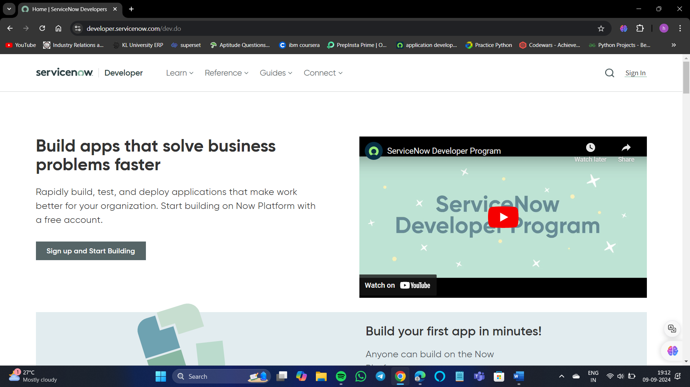

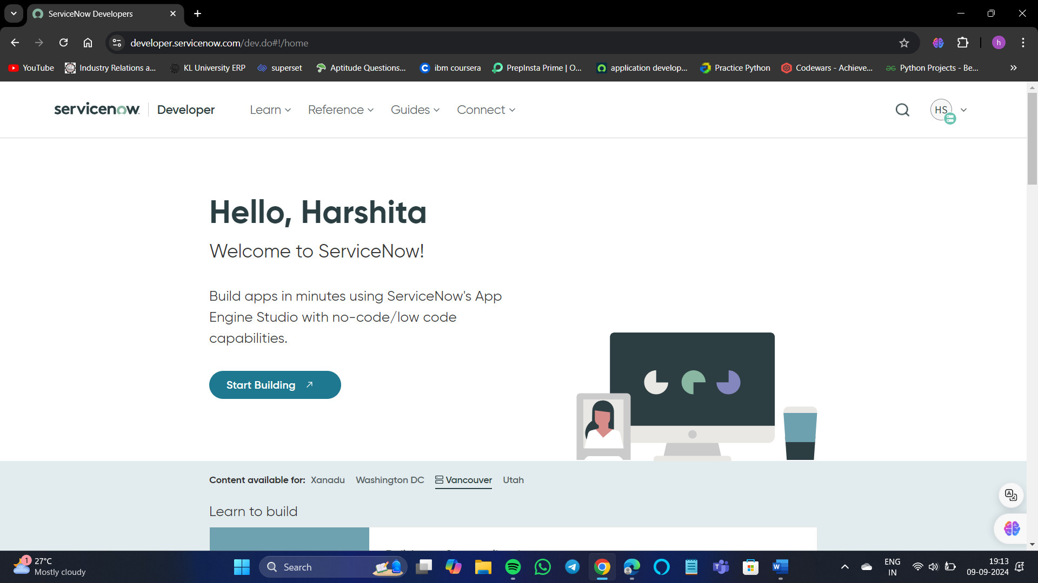

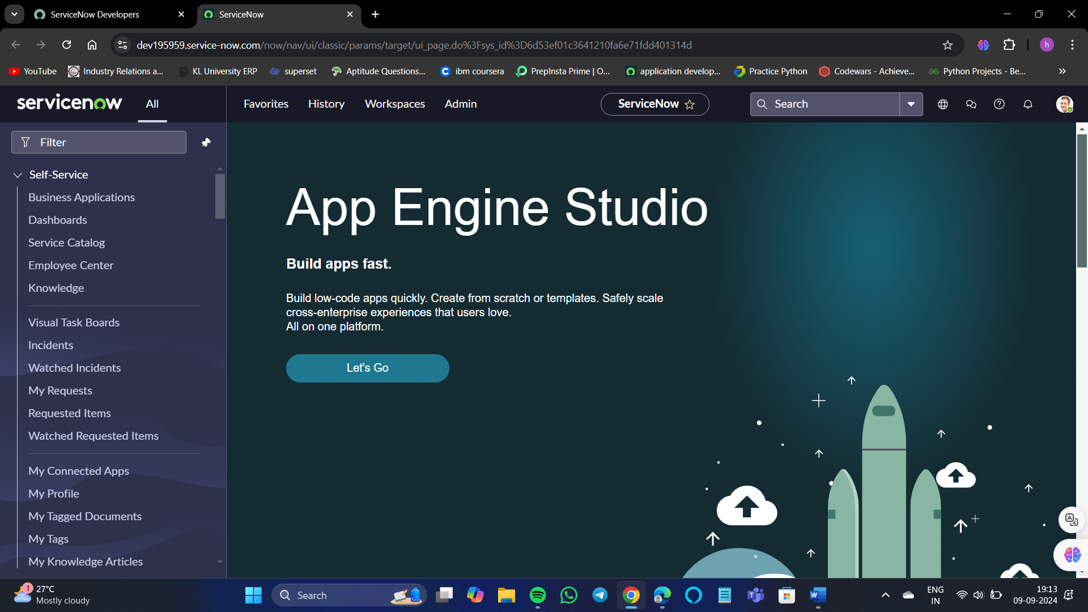

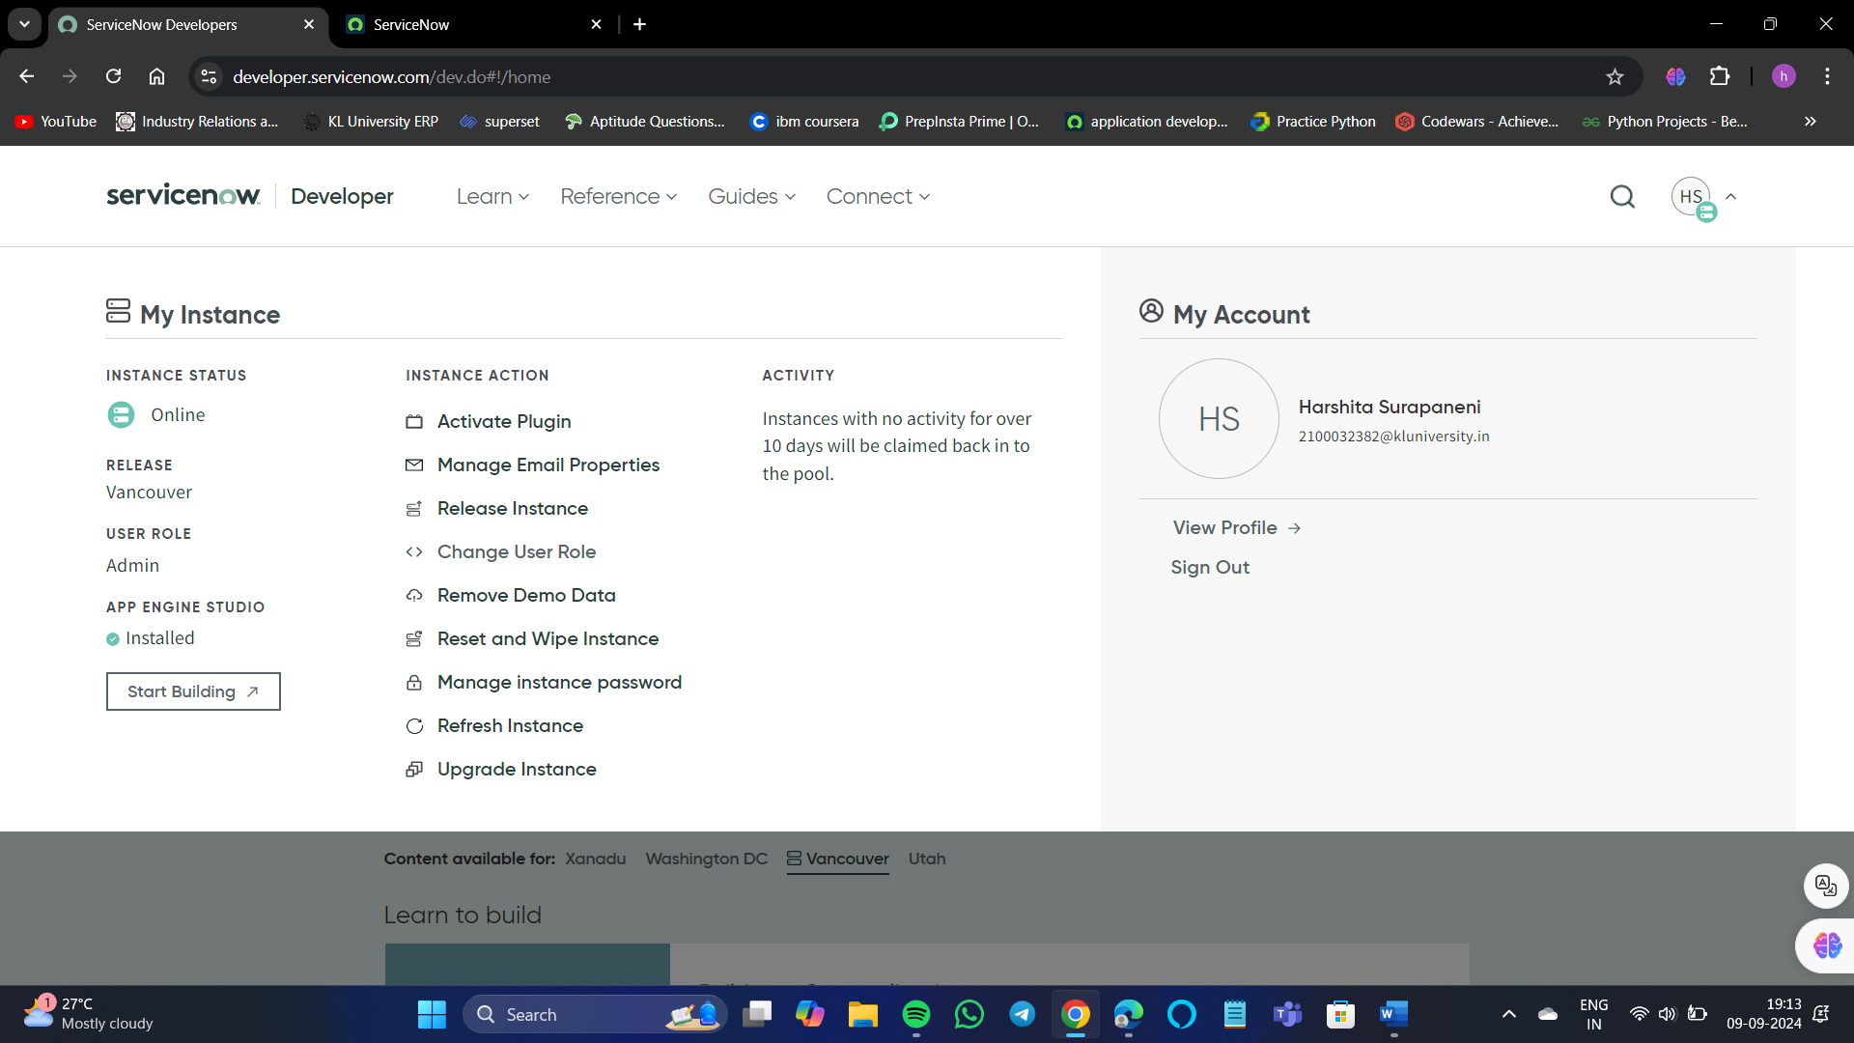

While creating an instance make sure you are creating your instance in the Admin user role. You can access all the options available on the Now platform.

If by mistakenly you have created your instance in Creator user role then you can chance it as shown in the above photo.

It will take 2 minutes to create your instance at once. And our ServiceNow instance portal looks like this after requesting.

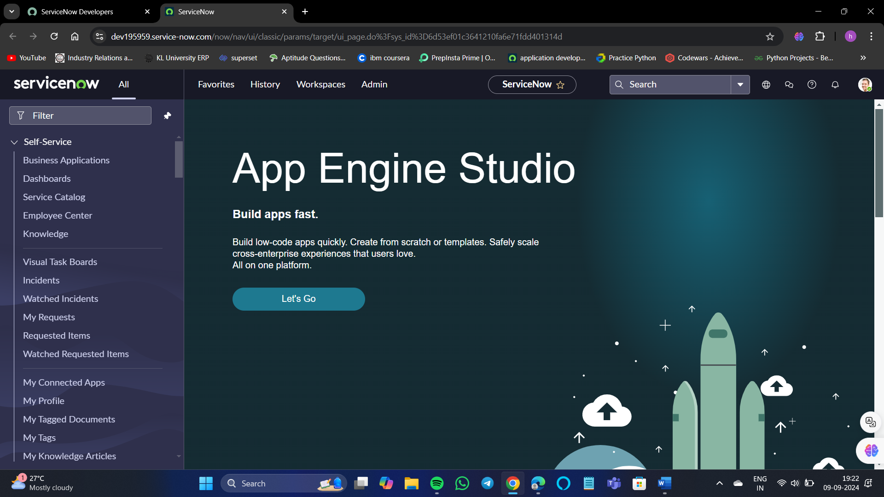

**Career and growth in ServiceNow:**

* ServiceNow is expected to continue to grow even in future.
* Currently, Cloud Platform is very popular.
* In the cloud platform, ServiceNow is the best tool to use because of its simplicity and ease of use.
* ServiceNow fits best in industries like:

1. Governance
2. Computer Software
3. Insurance
4. Health care
5. Information technology and services

**ServiceNow UI Overview:**

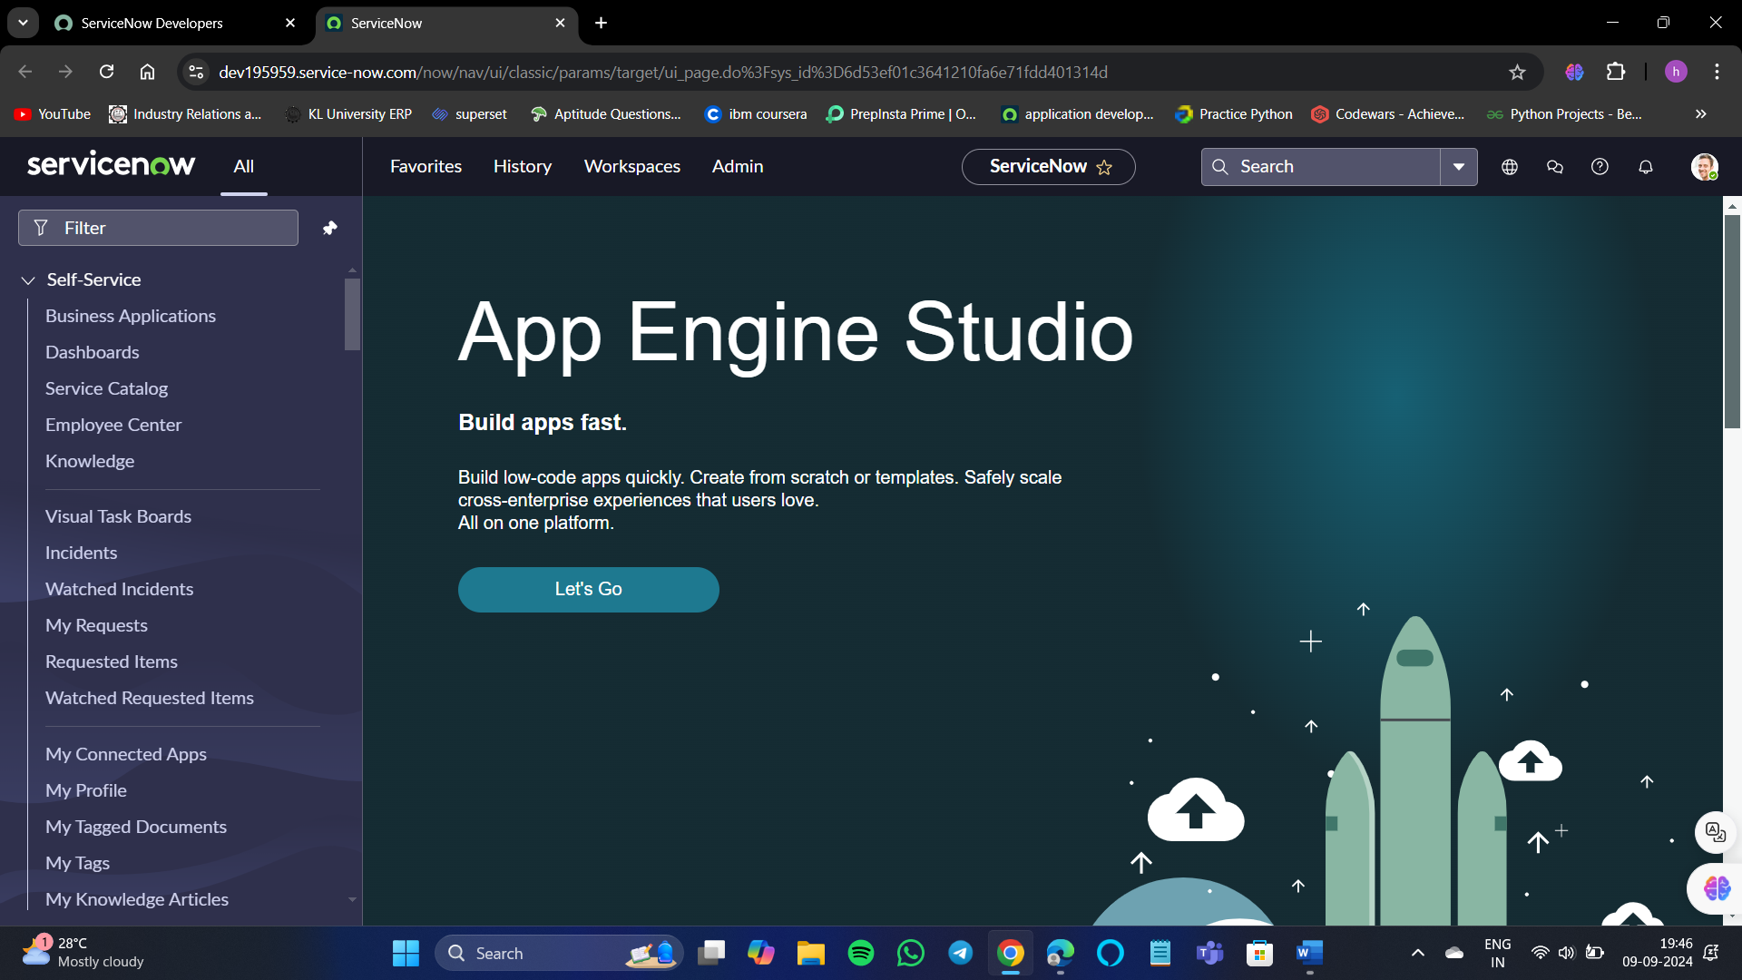



1. Banner frame:

The top header of the user interface that displays a variety of information, including:

* Logo: The company's logo

* Navigation: Global navigation menus that allow users to access applications and modules

* User information: Details about the logged-in user

* Search: A global search field

* Help: A help section

* Notifications: A section for notifications

* User menu: A menu with user-related controls, such as profile, preferences, and logout

* Settings: A gear or cog icon that is useful for developers

1. Navigator frame:

A feature that helps users access the applications they have access to, such as incident requests, changes, and problems. The Application Navigator has three tabs:

* Applications: A list of applications that the user's role has access to
* Favourites: A list of applications that the user has favorited
* Recent: A list of applications that the user has recently accessed

1. Content frame:

Displays content pages when a user selects a module in the Application Navigator. The content frame is located within the ServiceNow frame, below the banner, and to the right of the Application Navigator.

**ServiceNow Components:**

* The components are the basic elements of your page.
* Components range from the basic elements like labels, and buttons to more complex experience components like lists and forms.
* These components can be added to your page to create or personalize your workspace or portal.

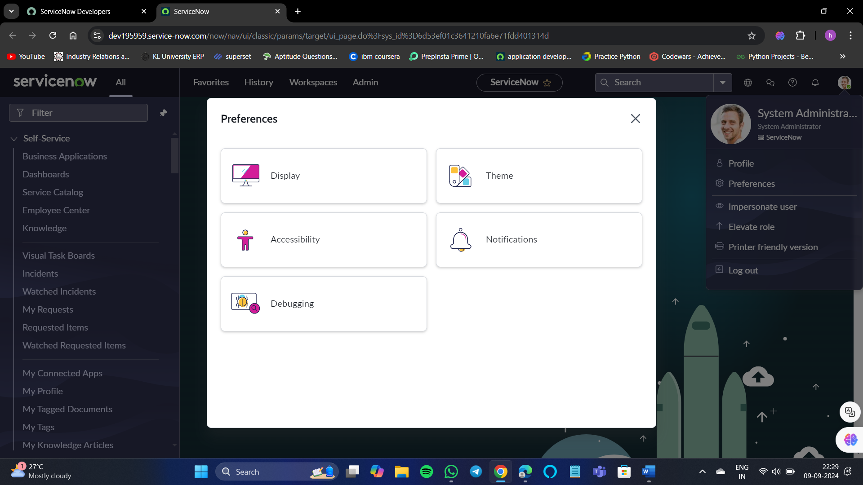

Here any user can change their portal and can present in different ways. It allows us to customize the portal.

For example, I want to change the default theme to a dark theme.

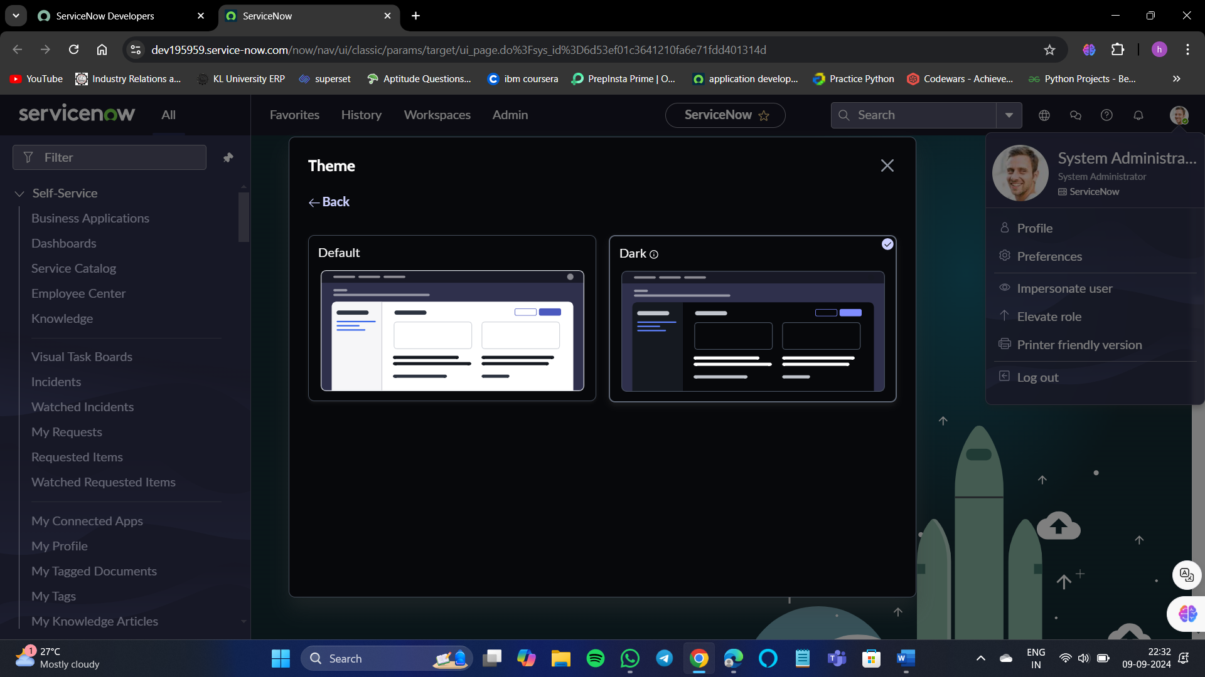

If you need any changes to be done in display wise we can do it here.

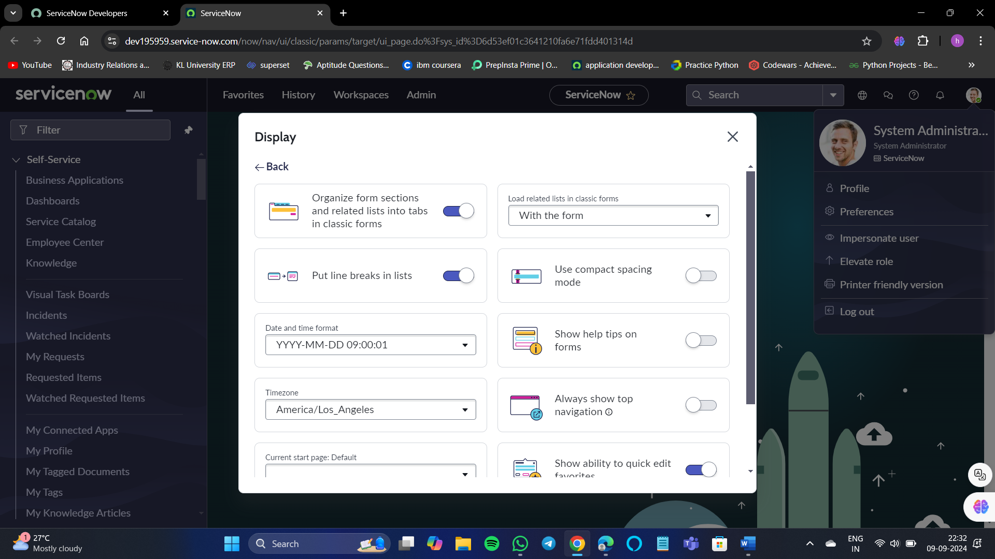

**Modules:**

There are many modules in ServiceNow some the main modules are:

* 1. Incident Management Module
  2. Problem Management Module
  3. Change and Release Management Module
* **Incident management** in ServiceNow involves a structured approach to identify, analyze, and resolve incidents that could disrupt business operations. This process aims to restore normal service as quickly as possible while minimizing impact and maintaining service quality.

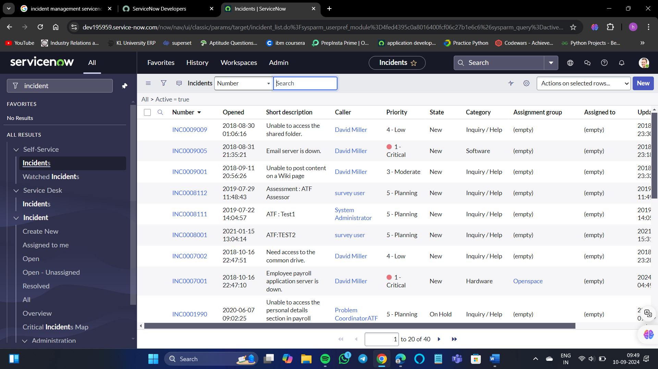

* ServiceNow's **Problem Management** application helps organizations identify and manage the root causes of service disruptions within their IT infrastructure. It utilizes ITIL-proven practices to minimize the business impact of service disruptions and aims to prevent future incidents by employing preventative measures and analyzing underlying causes.

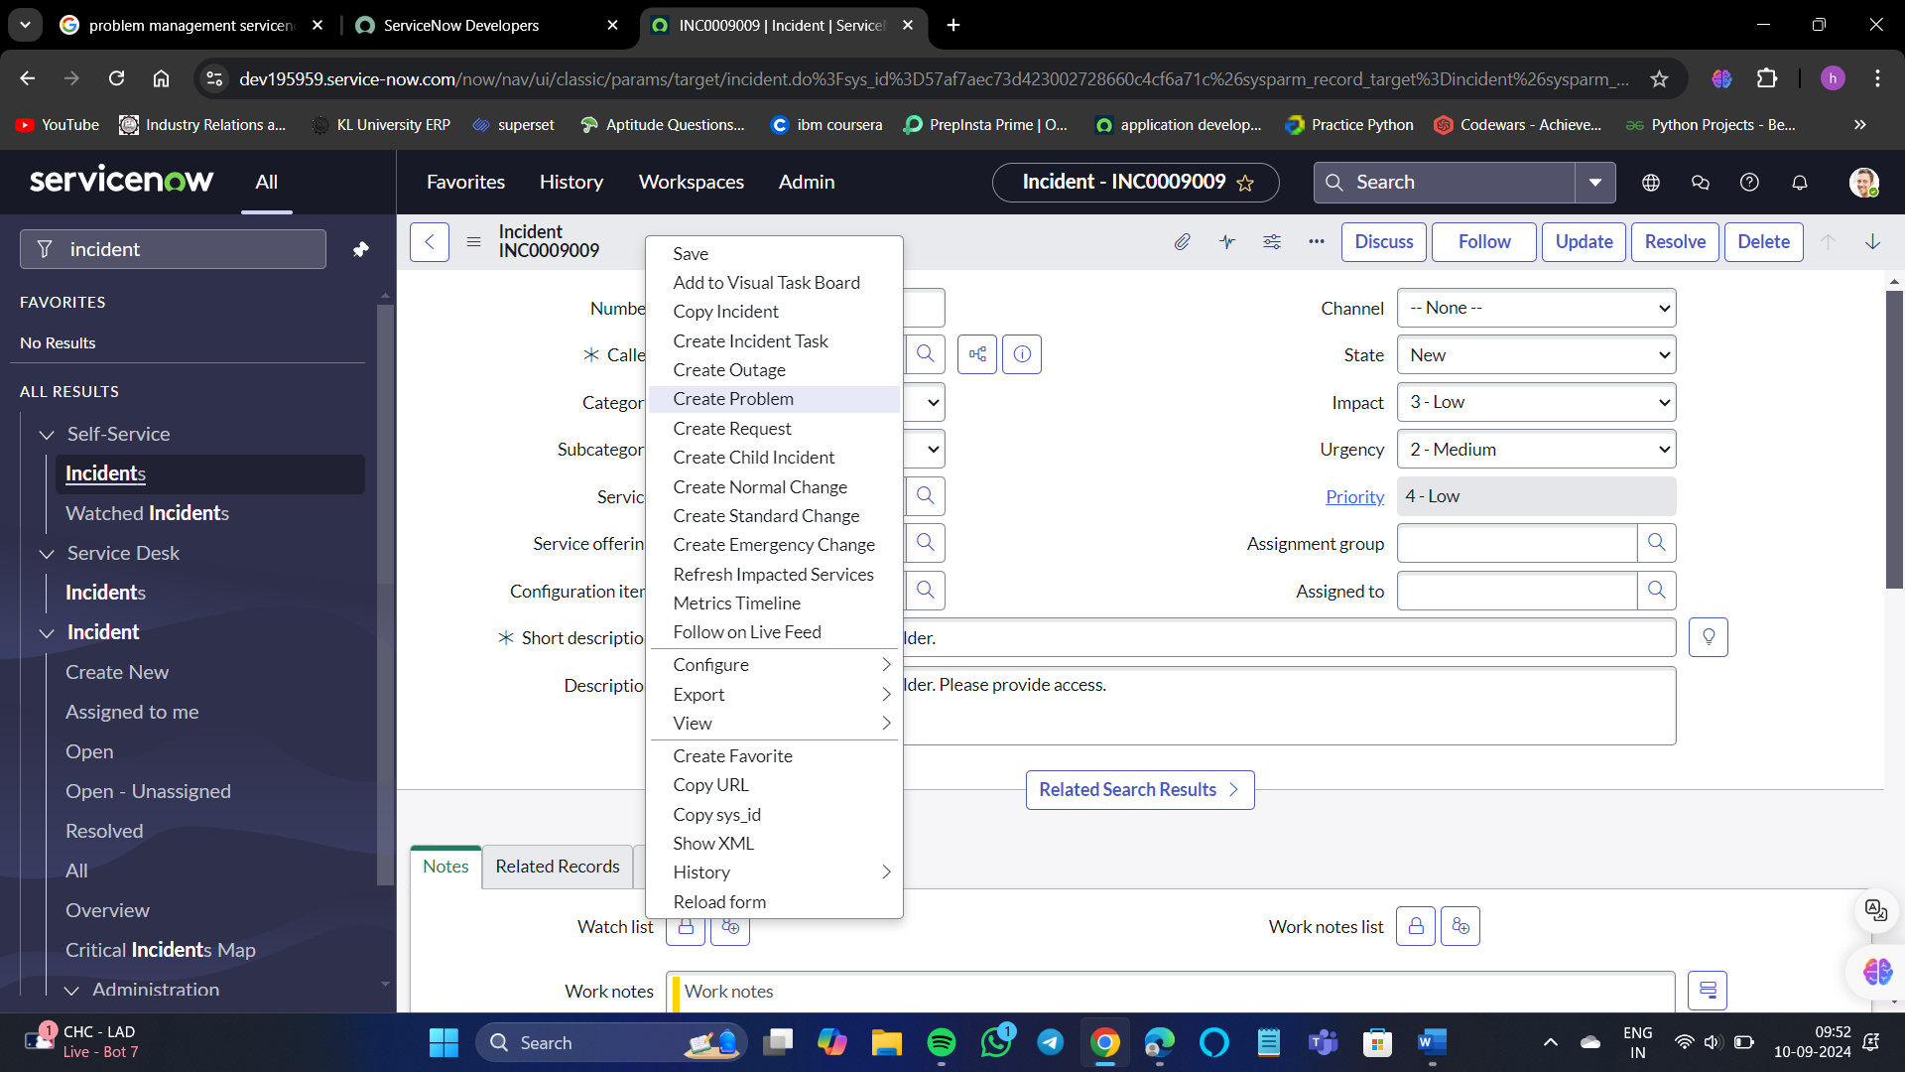

In incidents select any one of the user, and give a right-click on the banner. We can see a huge list of options.

Select **create problem.**

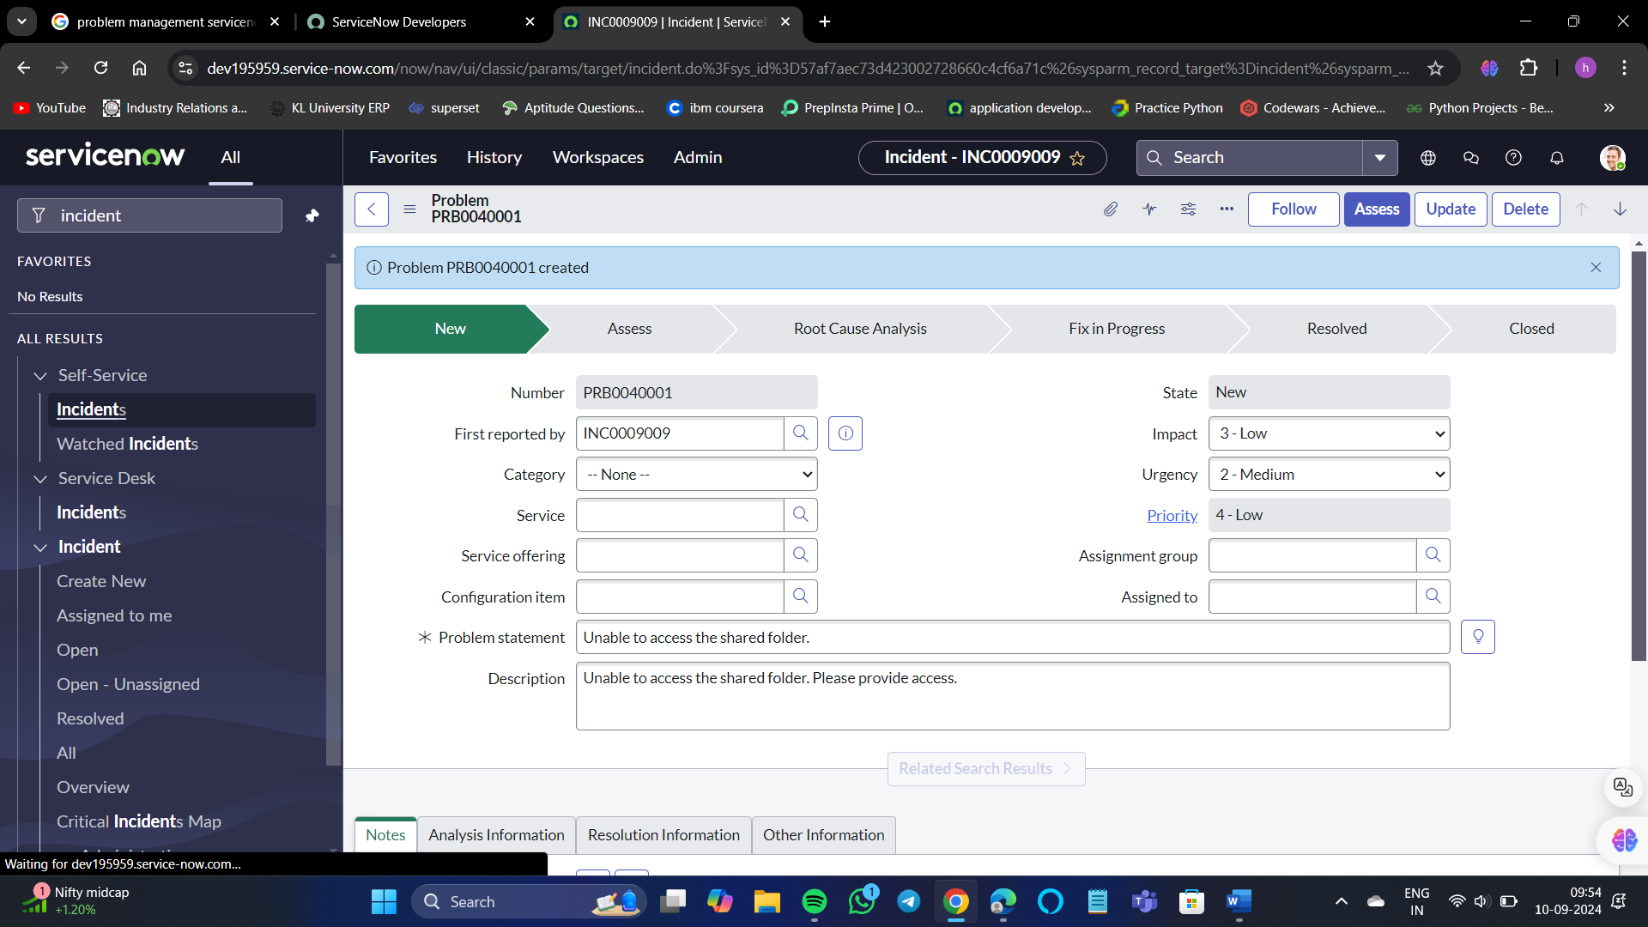

* **Change and Release Management** involves systematic processes to effectively manage changes to IT services and software deployments. Change management focuses on the planning and implementation of changes within the IT infrastructure to minimize risk and improve service delivery. Release management, on the other hand, is concerned with the planning, scheduling, testing, and deployment of software releases to ensure smooth transitions and updates. Together, these processes help in delivering products and services efficiently while controlling risks and costs.

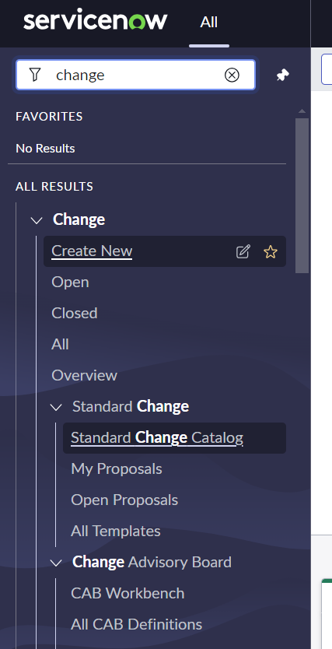

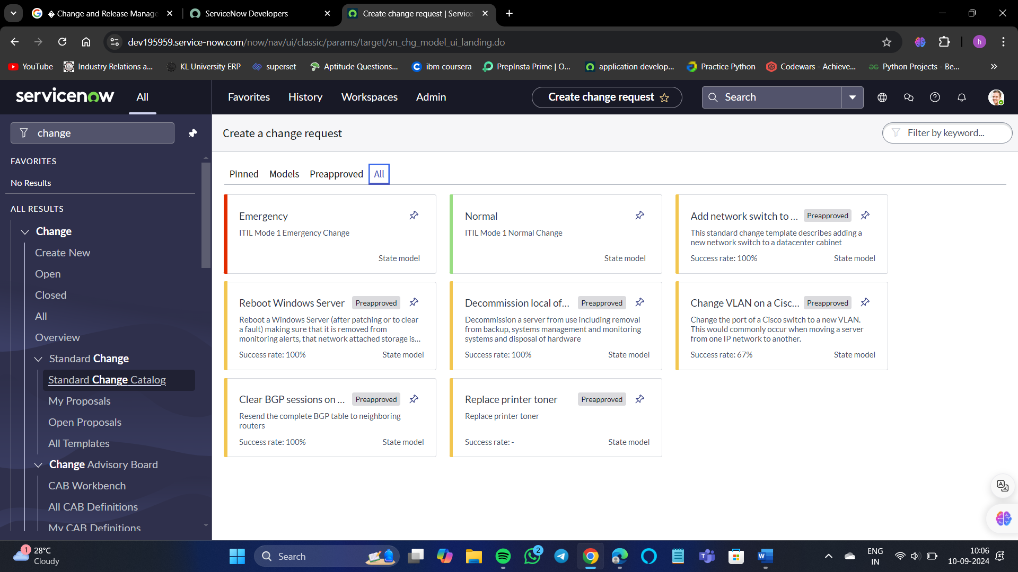

**Lists:**

* A list displays a set of records from a table.
* Users can search, sort, filter, and edit data in lists.
* Lists can be integrated into forms and can have sub-lists.
* The list interface includes a title bar, breadcrumbs and filters, columns of data, and a footer.
* Every column in a list represents a field in the table.

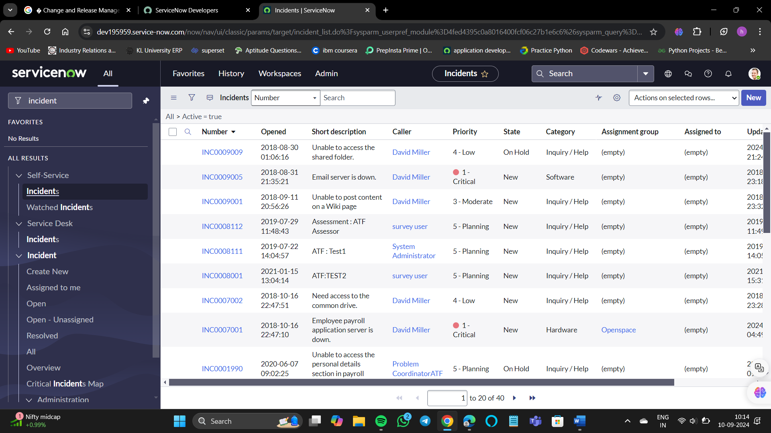

As you can see here, there are total of 40 records. If for example there are 400 or 500 records it will be difficult to search for a particular record.

So, we can filter the data of our choice.

For example, I want to display category – software, then select the filter icon and choose the category.

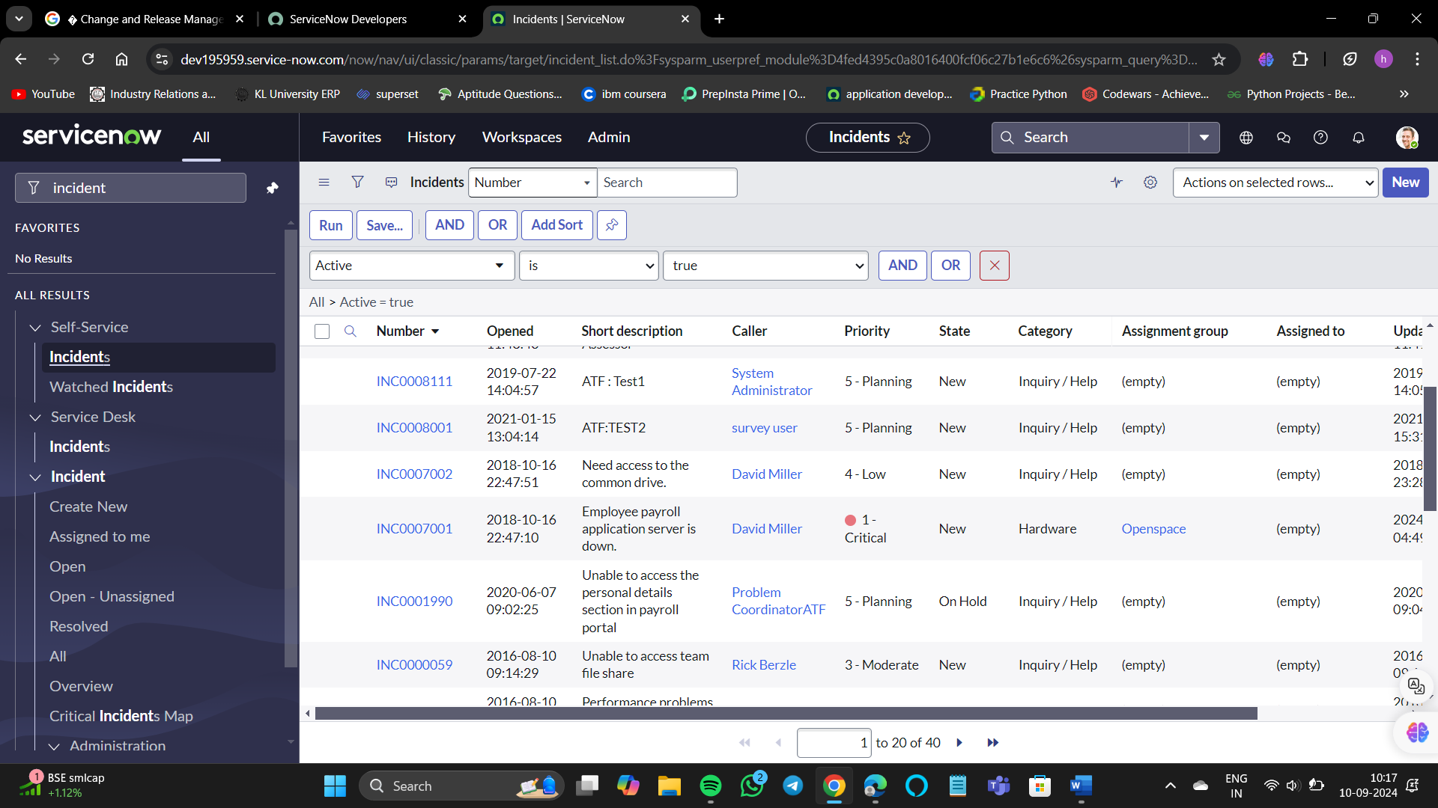

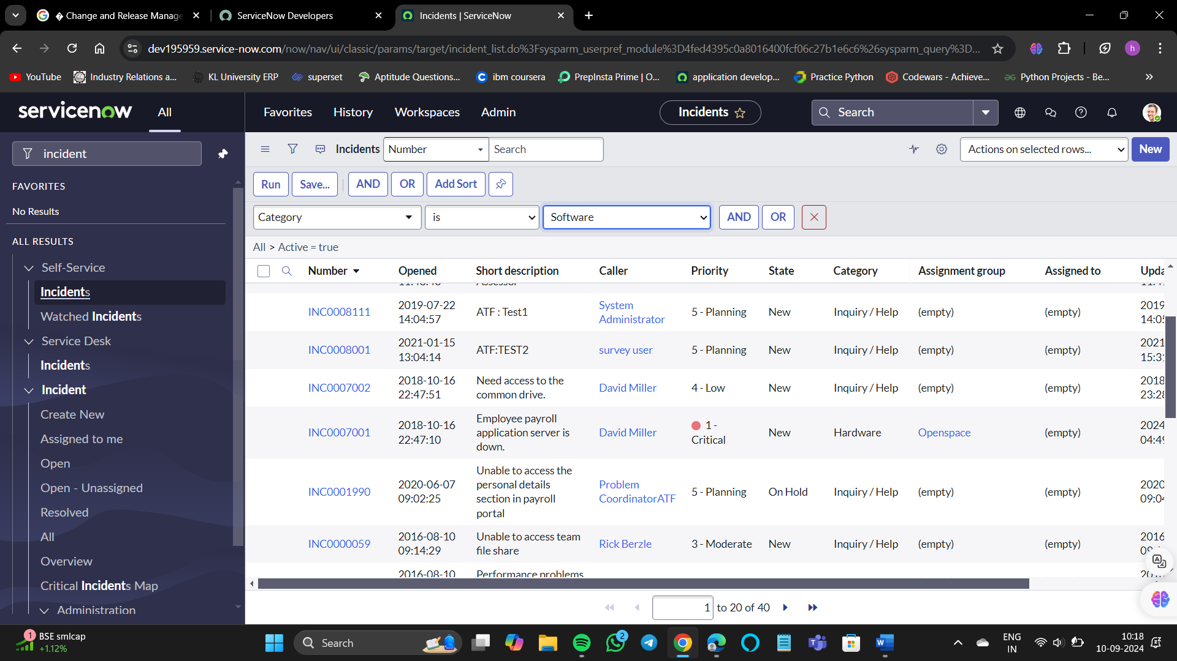

Then run the condition.

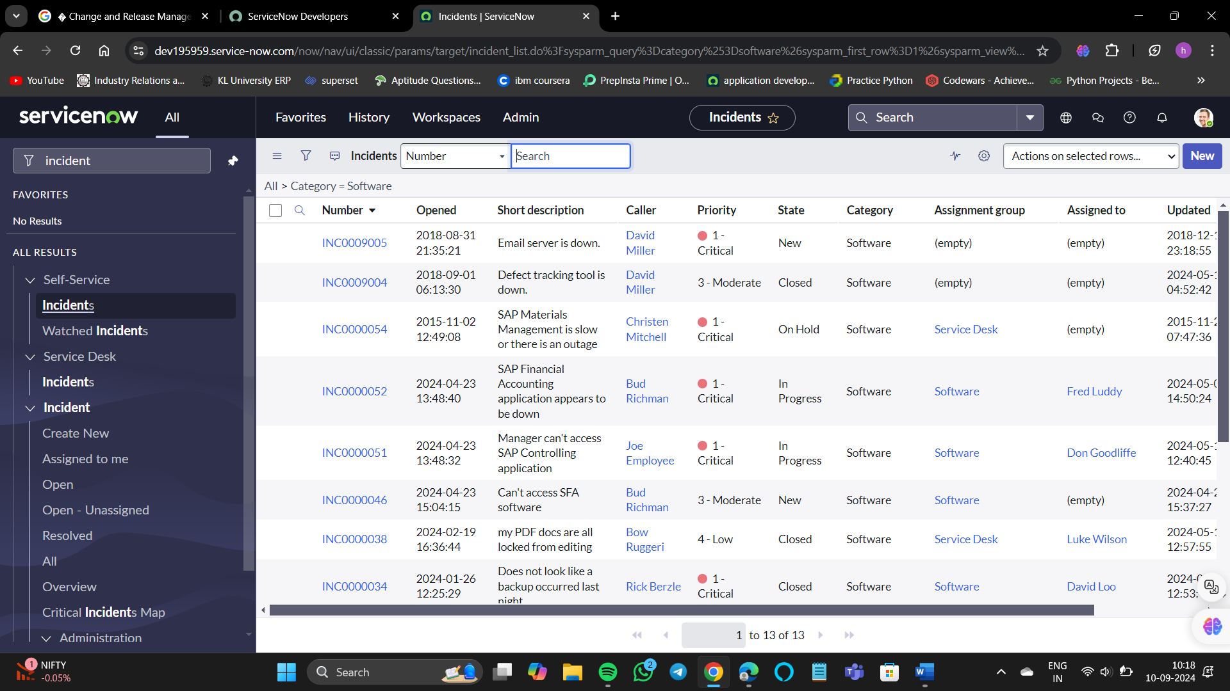

Now we have all the details which have software in their category.

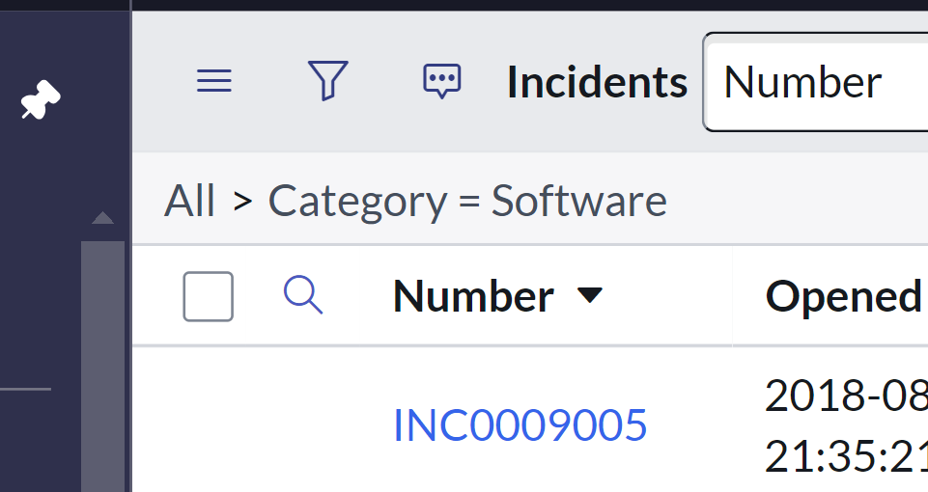

That greater-than symbol is called as breadcrumb.

Breadcrumbs in ServiceNow serve as a navigation aid that shows users the hierarchy of pages within the portal. They are arranged from left to right, with the leftmost item representing the most general category and the rightmost item signifying a more specific one. This design allows users to quickly navigate back to previous sections or understand their current location within the hierarchy.

If we click on that symbol again the filter will be removed.

If you want to you can group by with anything, I want to group by with category.

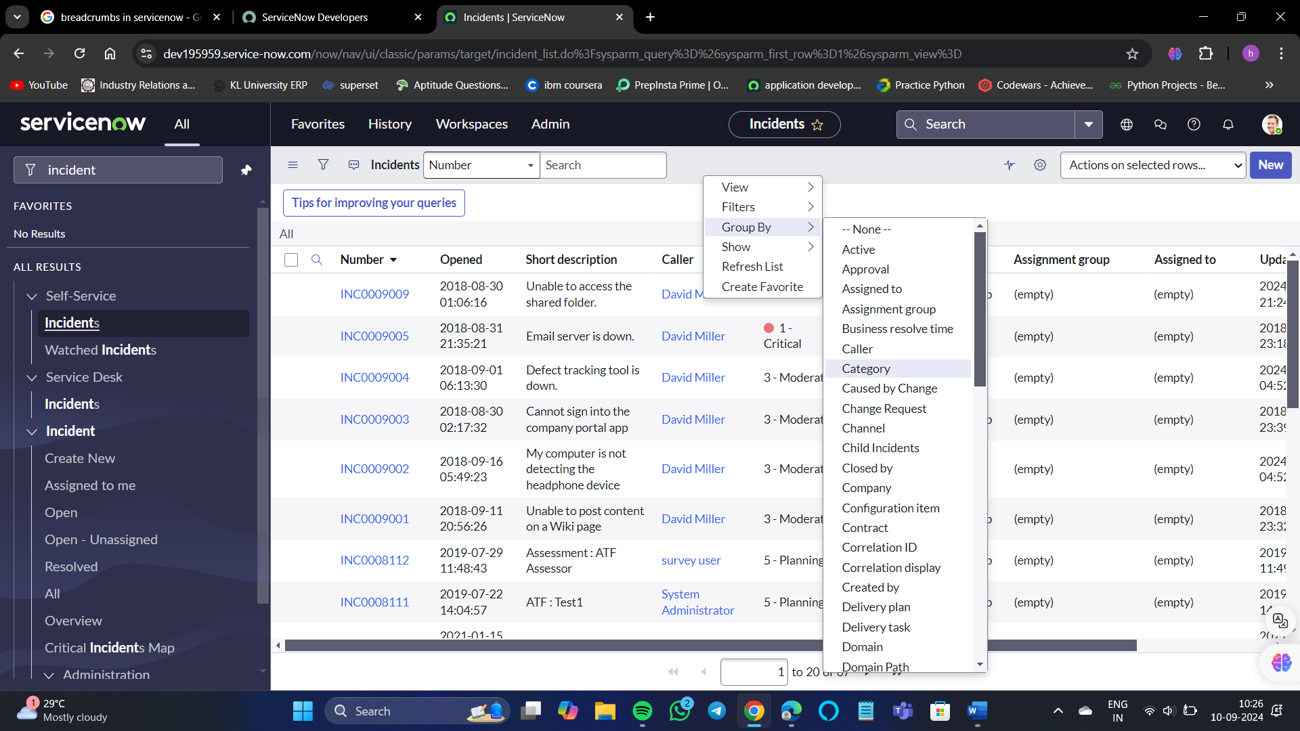

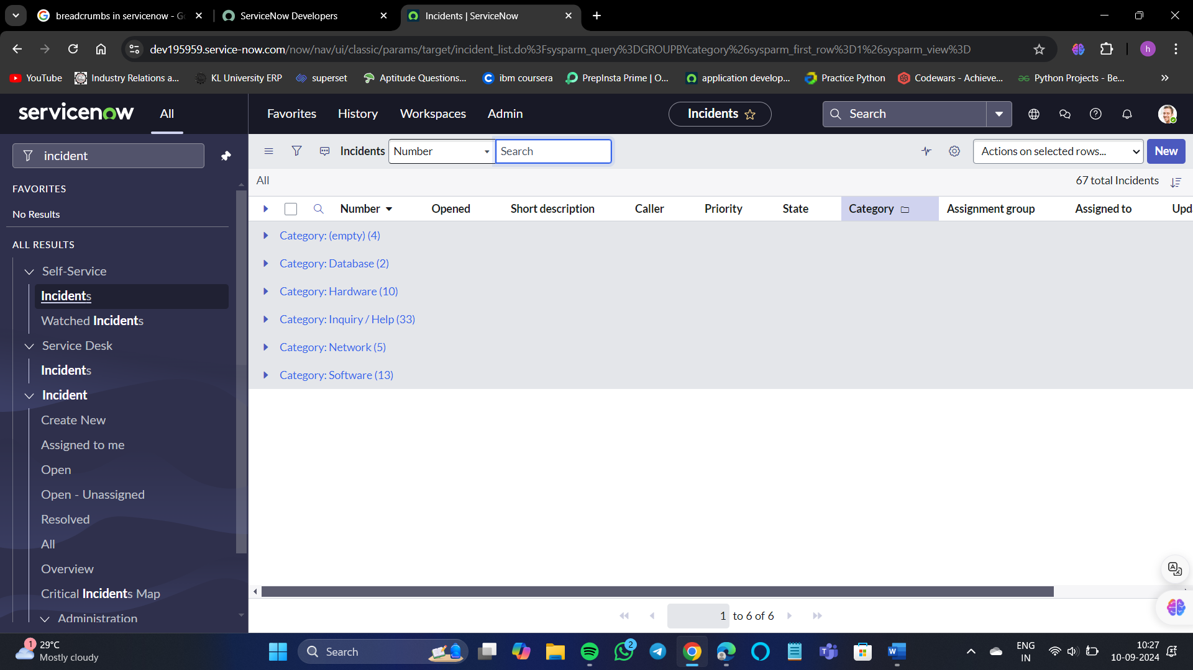

We can see all the data of the category.

If you want to create a favorite for this incident page, right-click on the banner again.

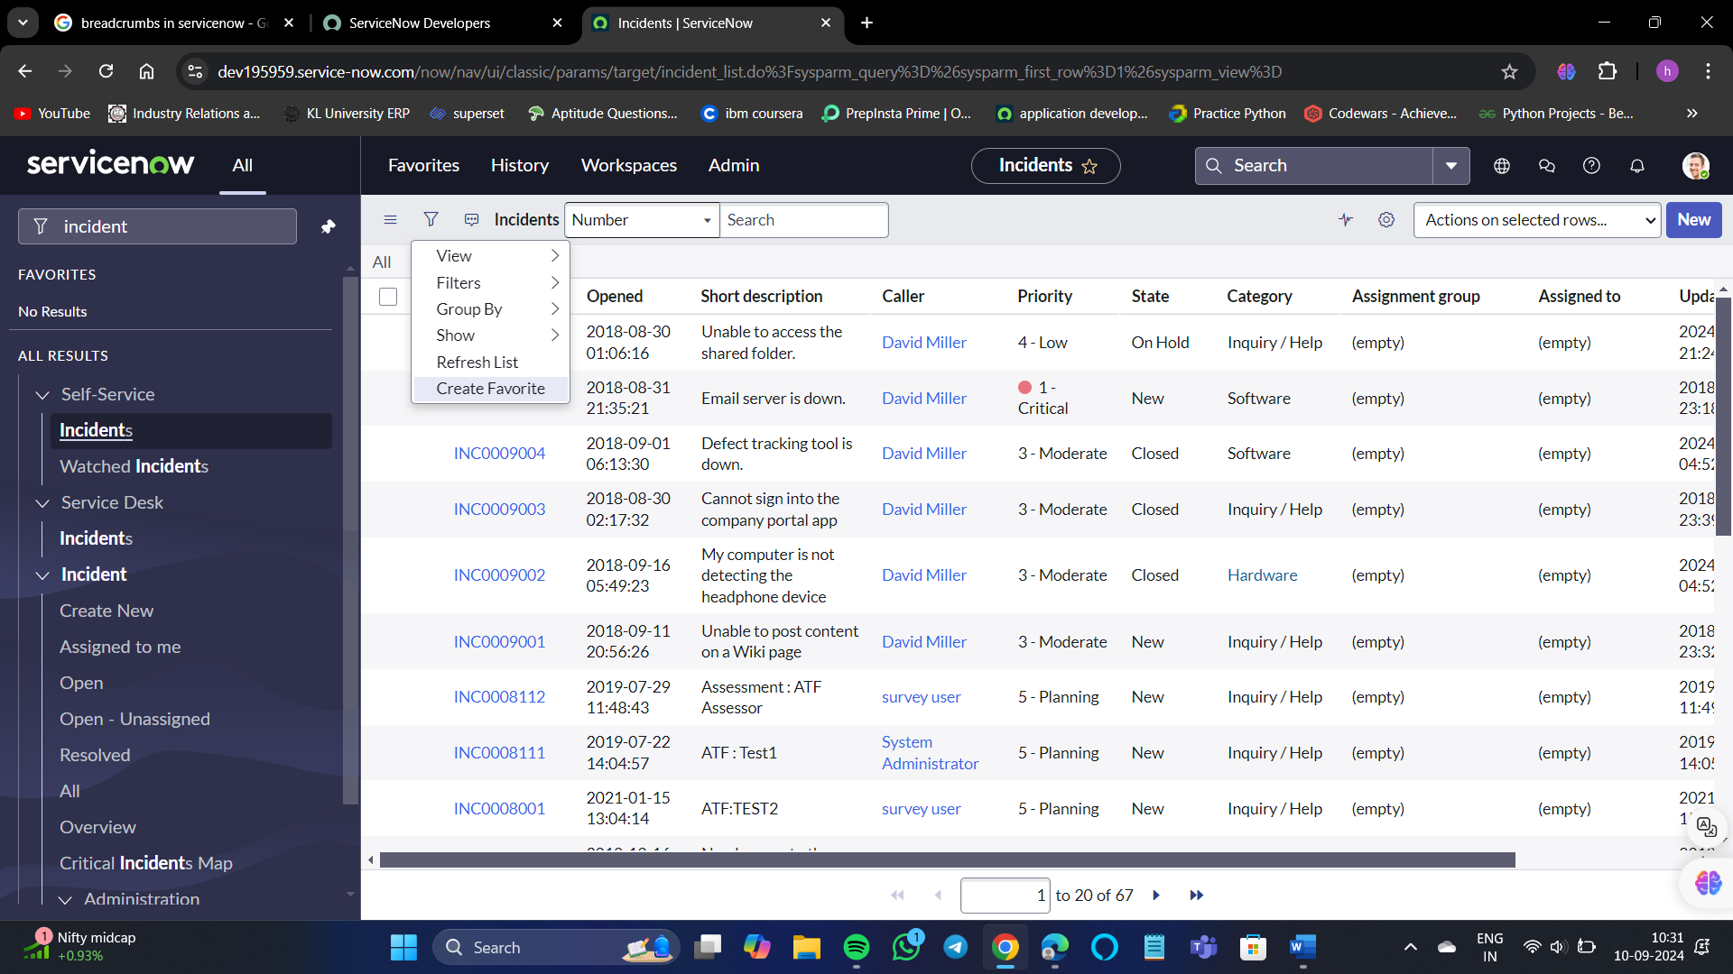

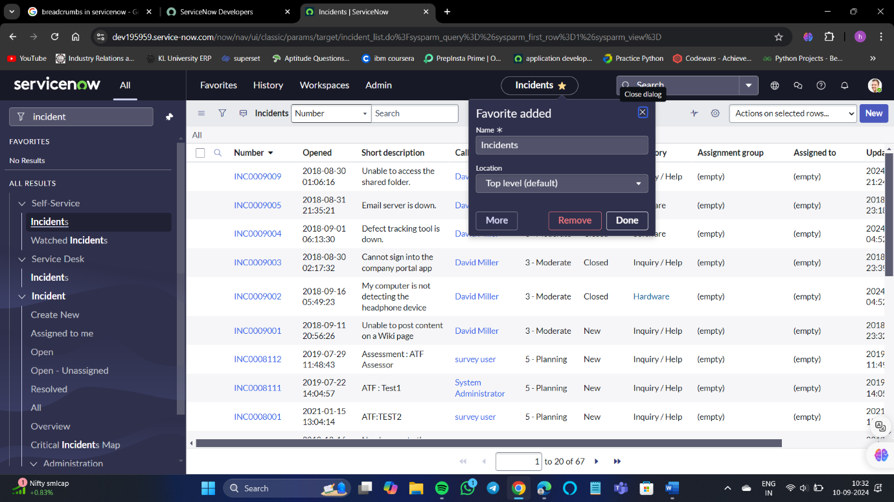We can see the favorite items in the navigation frame.

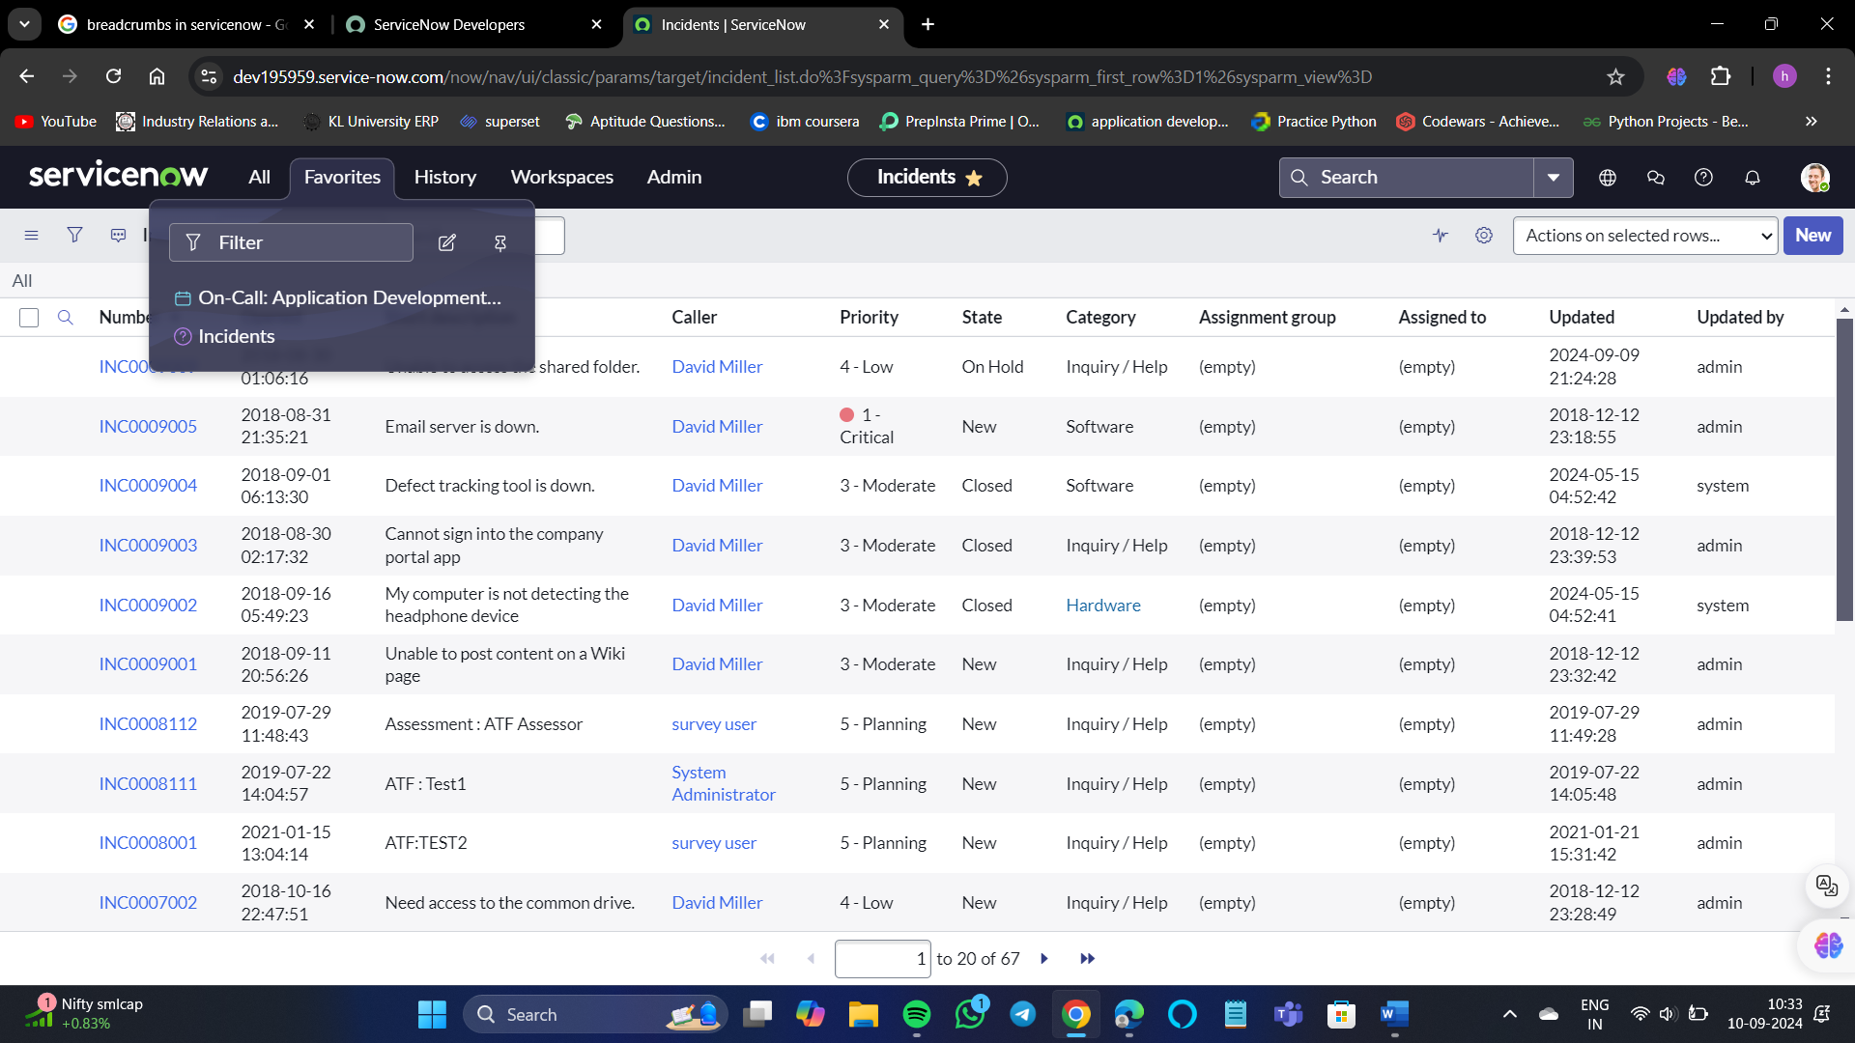

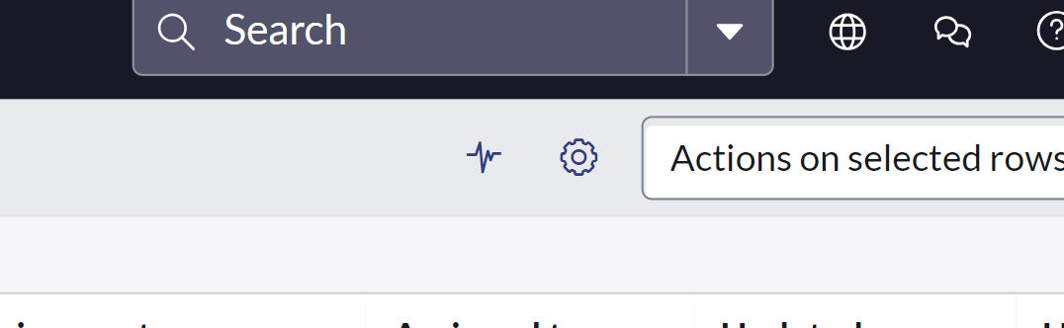

That symbol is called as Activity Stream.

Beside to Activity Stream we have personalize list.

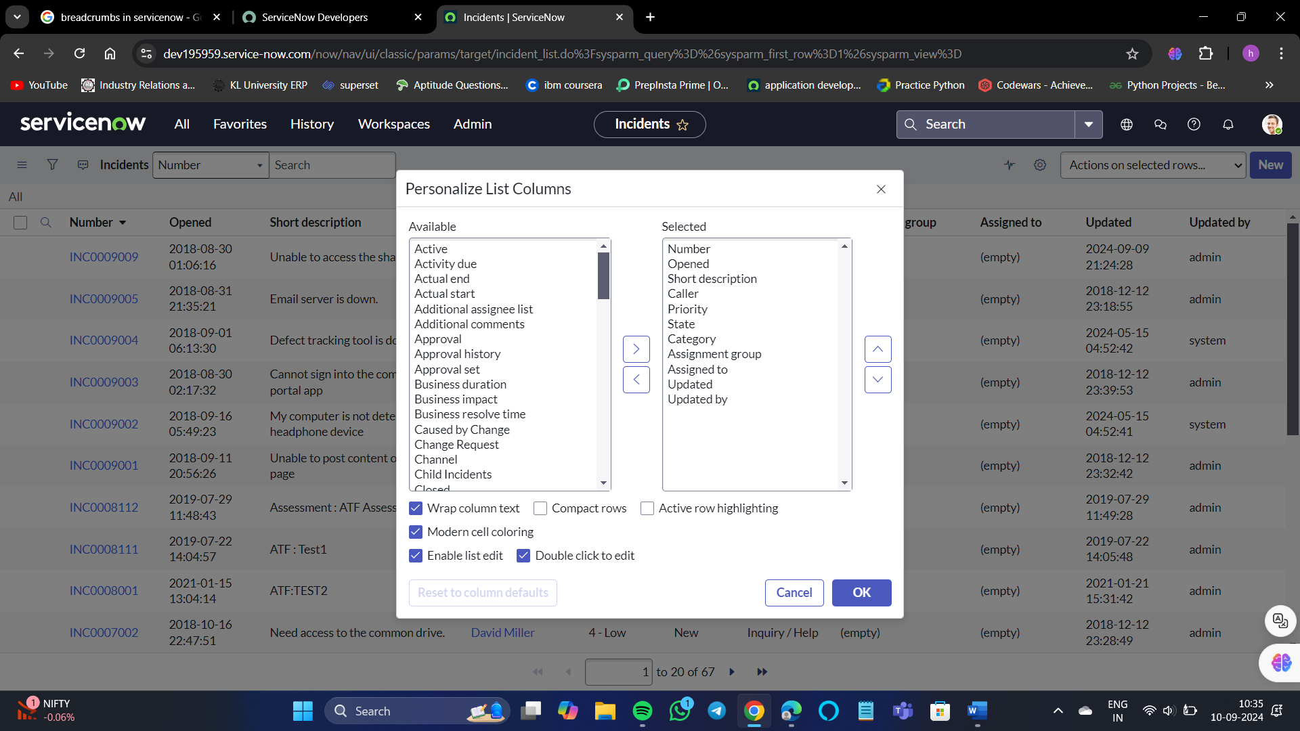

We can see here there are 2 list columns. One is available and the other is Selected.

For example, If I want to remove the “assignment group” and “Assigned to” columns,

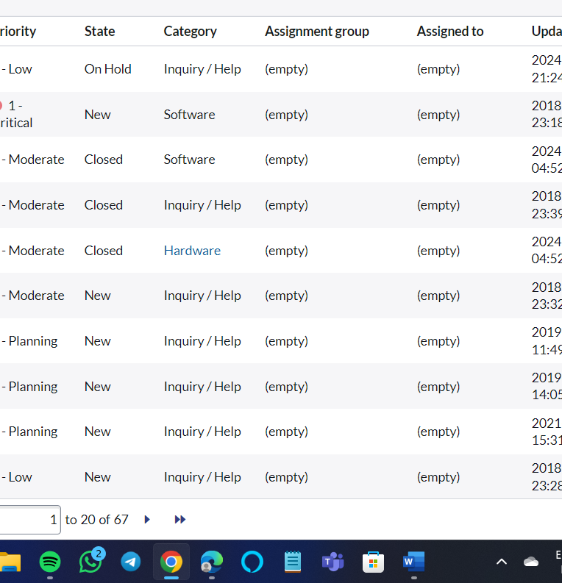

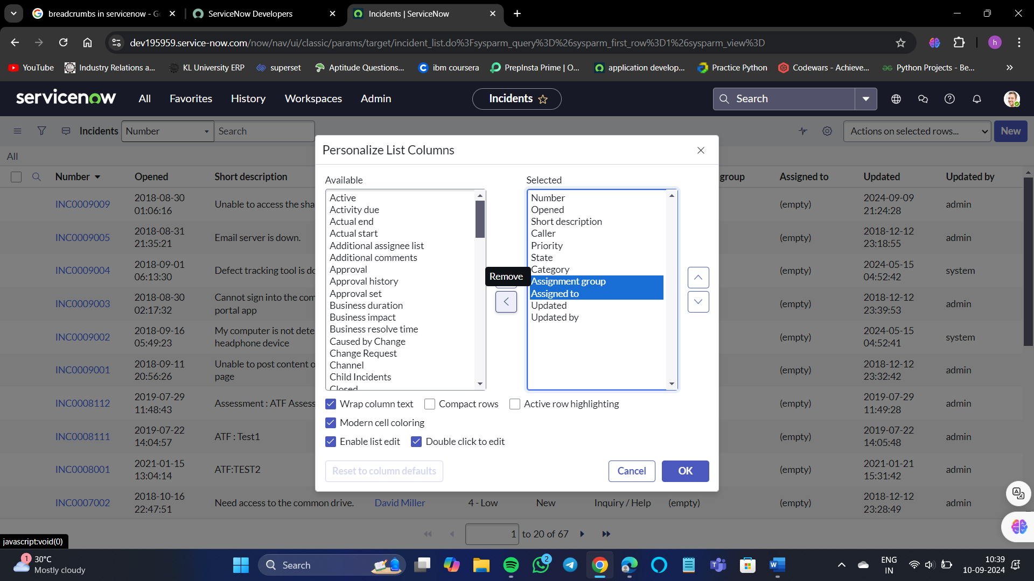

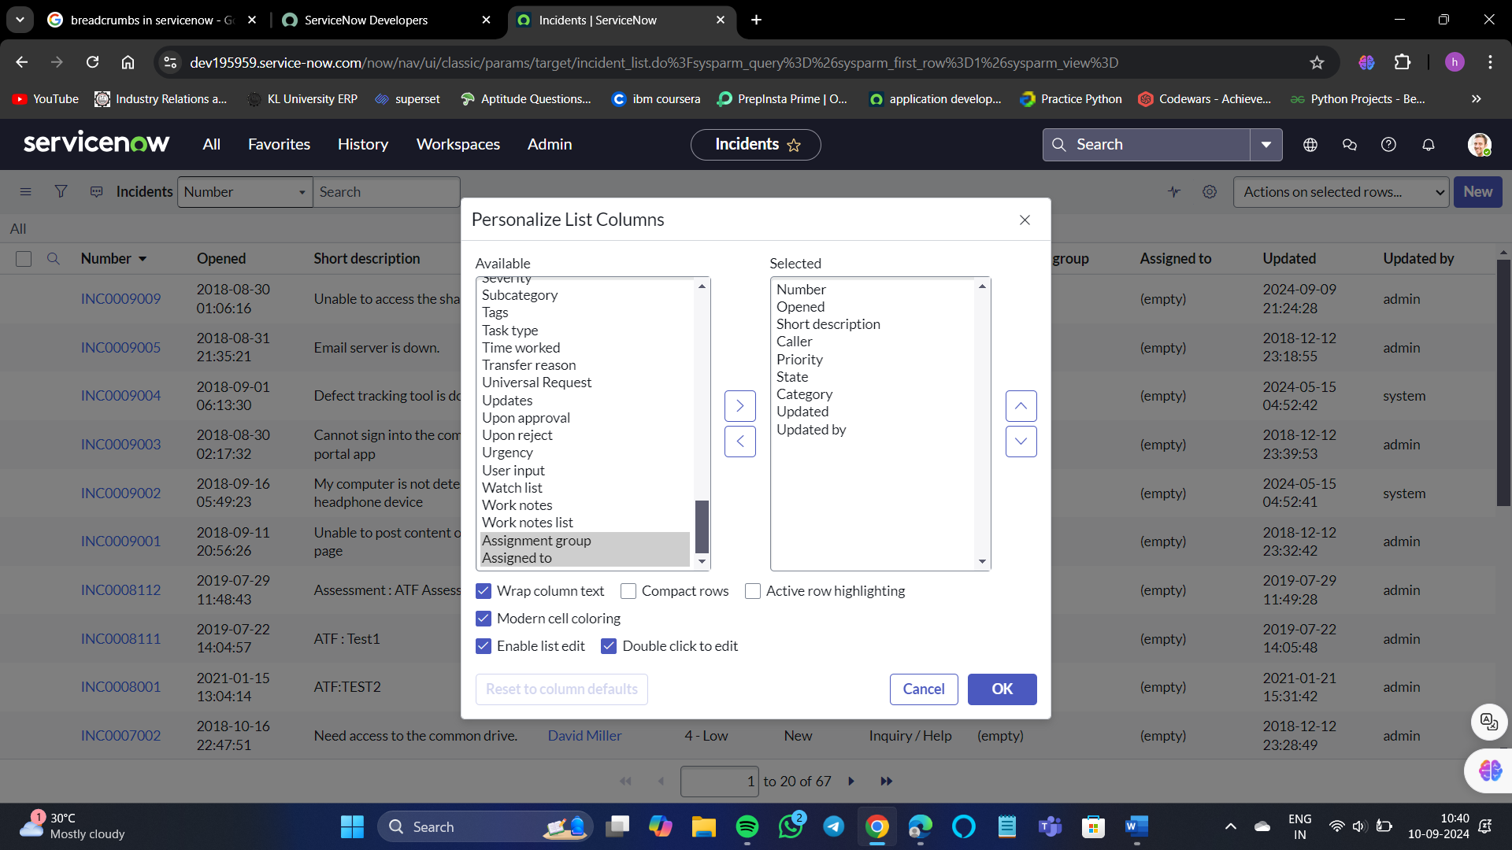

So, now those 2 columns have been removed from selected to available.

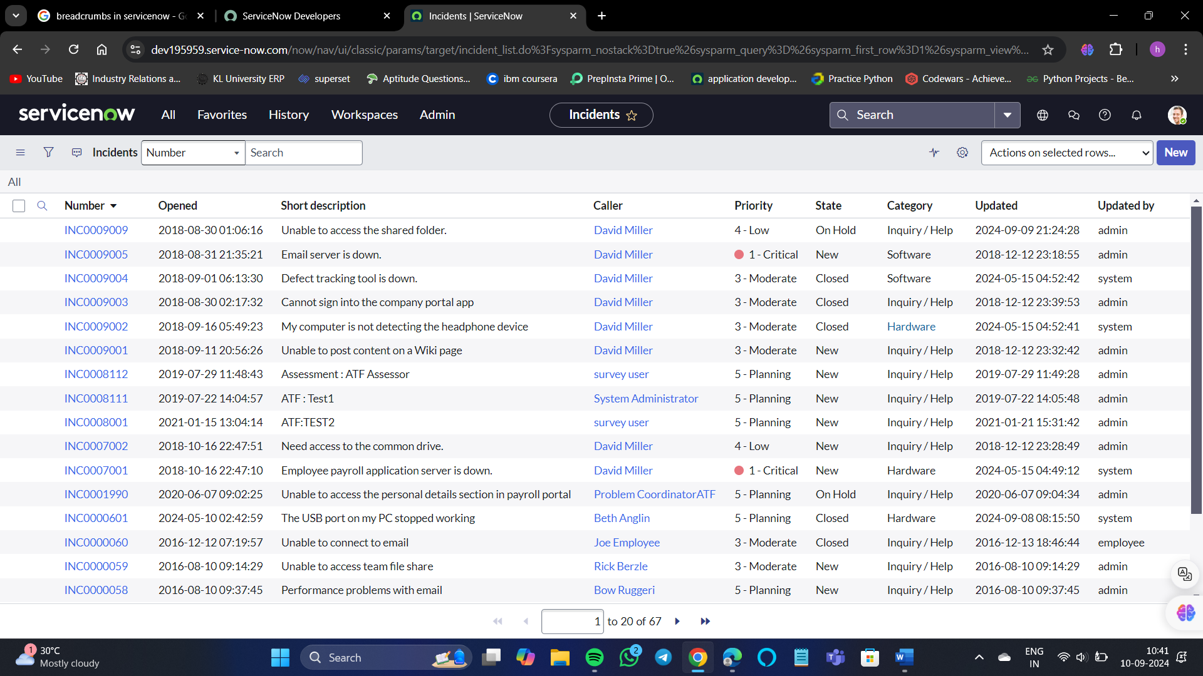

Removed successfully.

